Lab 2- Explore Available Data in the Lab Environment

Estimated completion time
- 15 minutes

Learning objectives
Upon successful completion of this lab, students will be able to:

- Use the query editor in the Starburst Enterprise web UI to explore available catalogs, schemas, and objects.

Prerequisites
- Lab 1: Access your lab environment

Activities
- Prepare for the exercise
- Use the Cluster explorer to view available data
- Use the options menu to explore data
- Use SQL to explore data

Step 1: Prepare for the exercise
- Sign in and verify that you’re using the students role.
- Navigate to the Query editor.

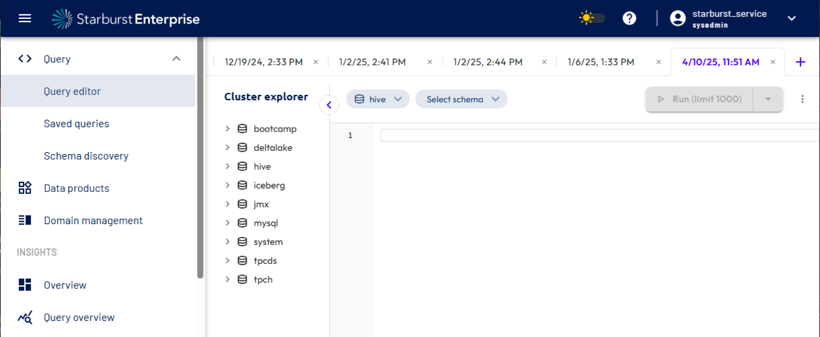

Step 2: Use the Cluster explorer to view available data
The Cluster explorer provides a quick and easy way to view all data available to you.

- Click to expand a few of the catalogs (indicated by a database icon). This will bring up a list of the schemas within each catalog. Oftentimes, a catalog will contain many schemas. The search bar for filtering schemas comes in handy in such instances:

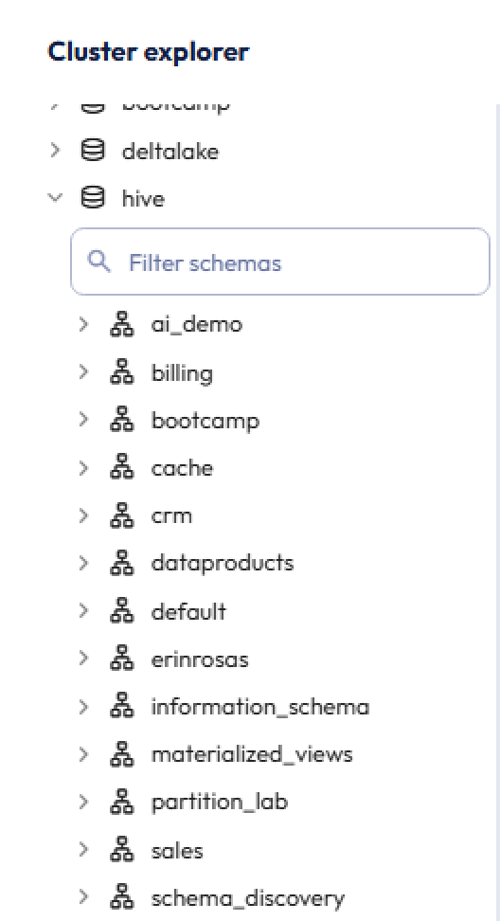

- Click to expand a few of the schemas. This will bring up a list of tables and/or views within the schema. A view is indicated by an eye icon, as shown in the image below. You can also click to expand the views and tables to see information about the columns, including data types.

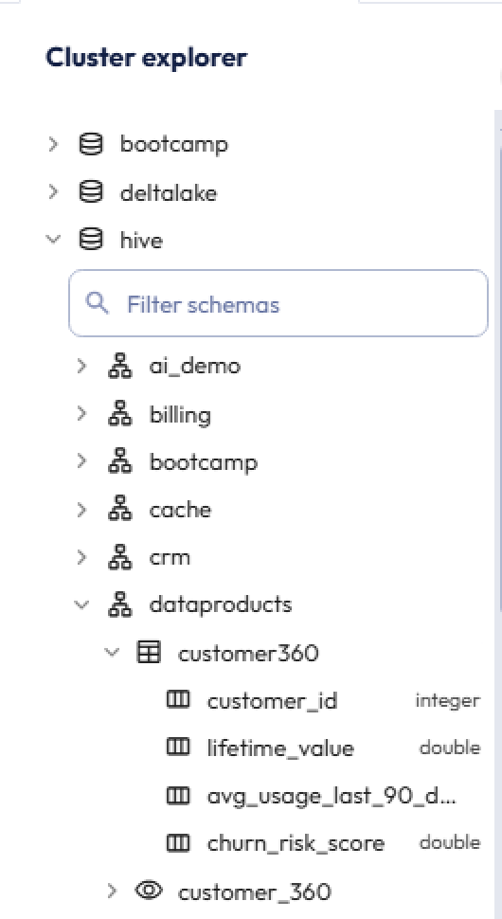

Step 3: Use the options menu to explore data
The options menu facilitates catalog exploration by writing simple queries for you.
- Hover over the customer_360 view to bring up a vertical ellipses menu.
- Click to open the menu, and select “Enter DESCRIBE customer_360”. This will copy the SQL to the query window.
- Run the SQL and view the results. You should see four columns and their associated data types.

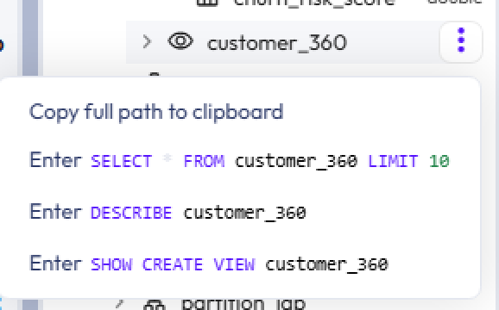
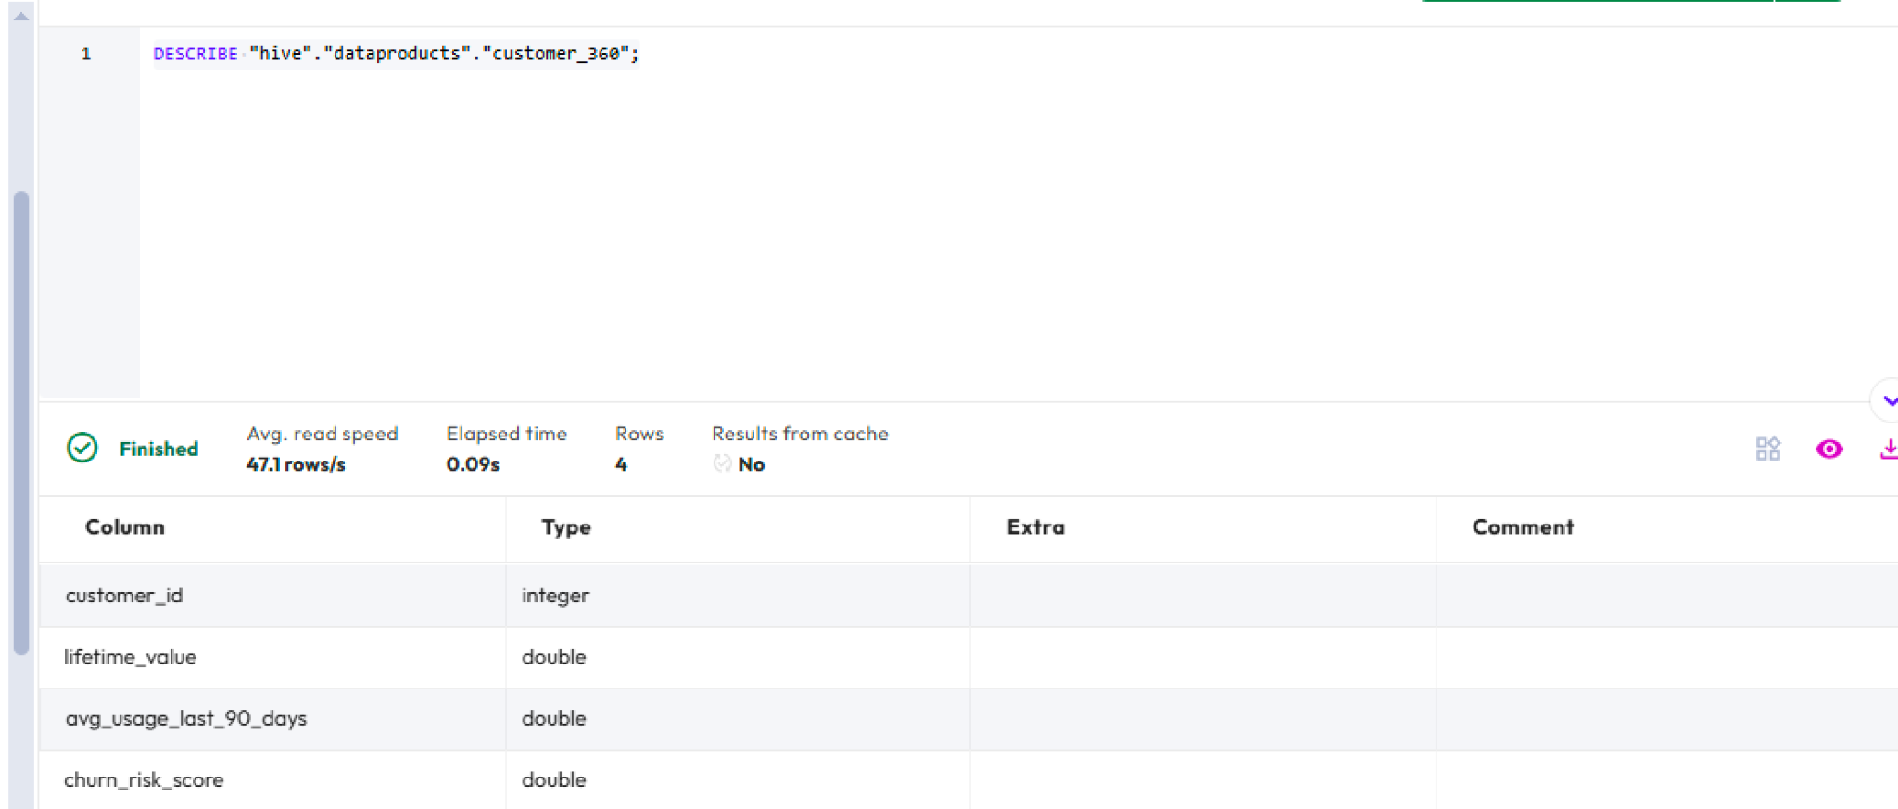
- Open the ellipses menu again, and this time choose “Enter SHOW CREATE VIEW customer_360”.
- Run the SQL and review the output, which will display the SQL statement needed to create the view.
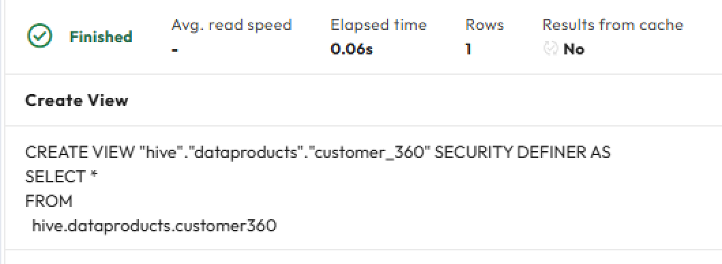

Step 4: Use SQL to explore data

- Run the following SQL to list all available catalogs:

SHOW catalogs;

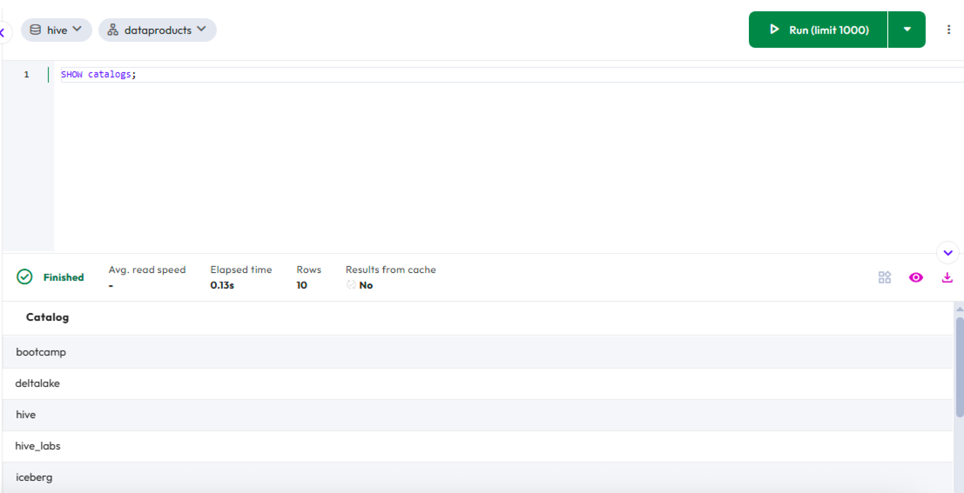

- Run the following SQL to drill down farther into one of the catalogs:

SHOW schemas IN bootcamp;

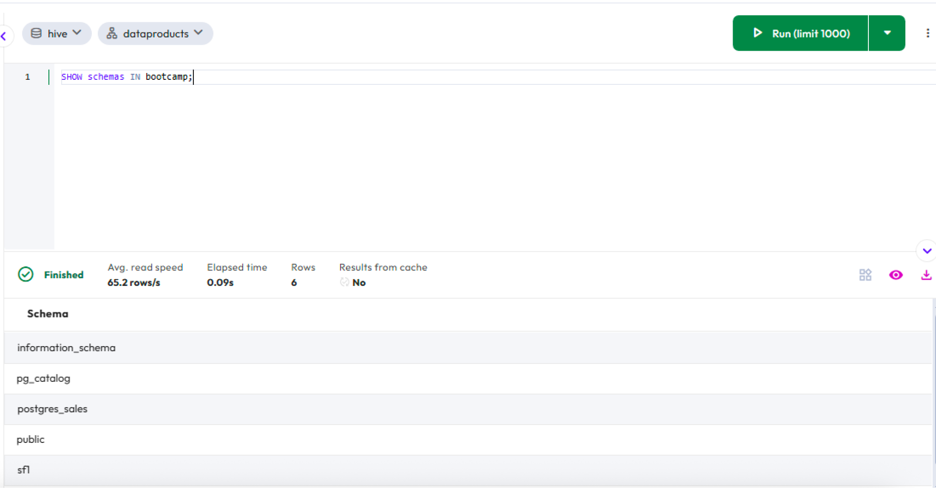
- And finally, run the following SQL to list all tables in a particular schema:

SHOW tables IN bootcamp.public;

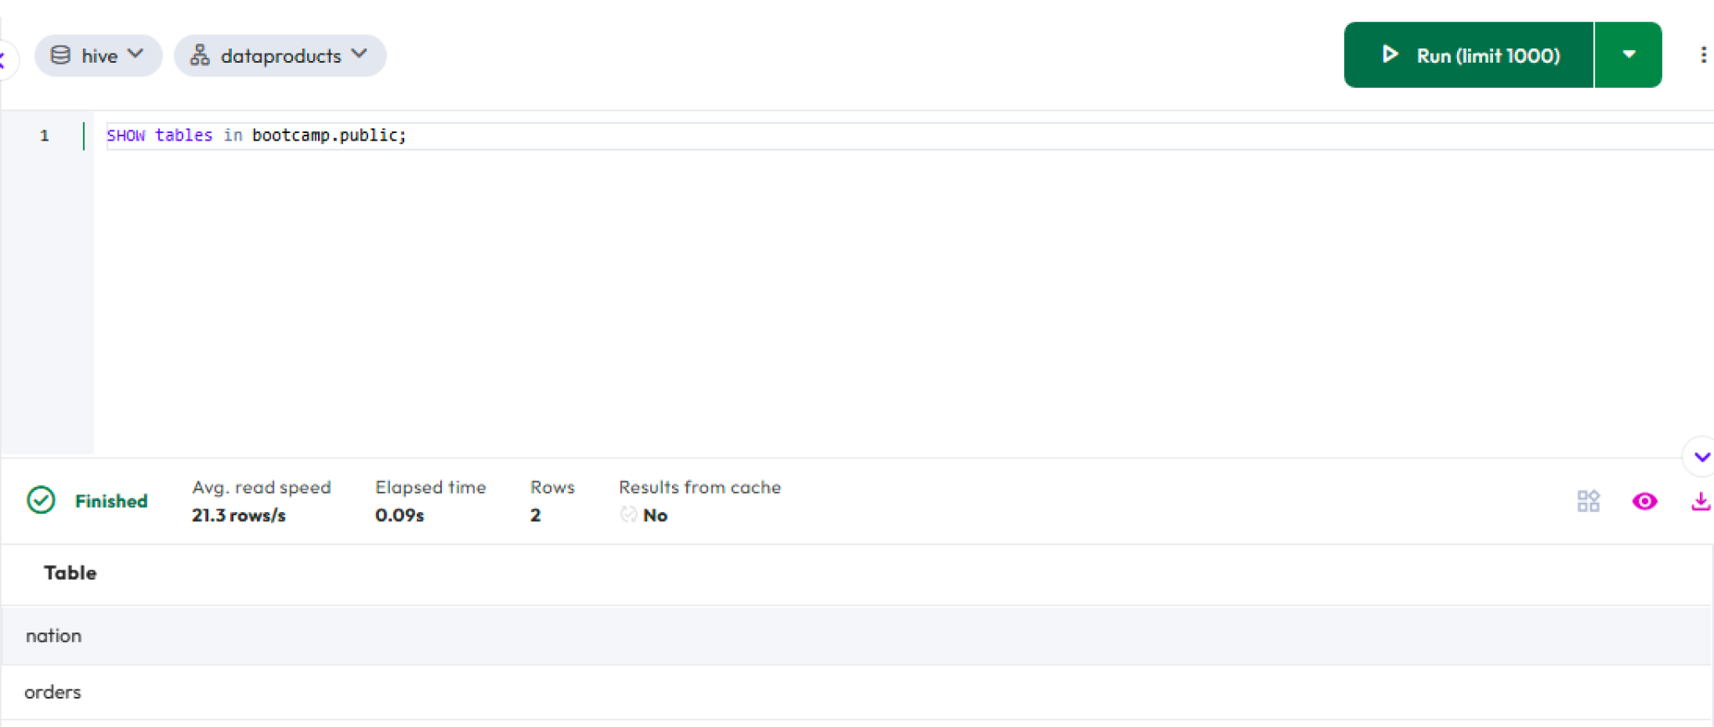

END OF LAB EXERCISE

